COMP1835
Lab 1
Testing Virtual Machine

In the labs of this course, you will be using two virtual machines, specially created for this module. First VM will be used for Redis, Cassandra and Mongo databases. The second VM will be used for graph databases. Each machine has a Linux operating system and necessary software installed. Each student will have their own virtual machine. In order to access your VM, you would need to login to Remote Desktop first.

The main purpose of this lab is to ensure that you can successfully login and navigate inside your first VM and are ready for the next labs.

Lab 1: Testing your Virtual Machine
1. Open Google Chrome Browser inside your Remote Desktop
and navigate to https://classroom-vc.gre.ac.uk/

On the next screen select Advanced and then Proceed to classroom-vc.gre.ac.uk

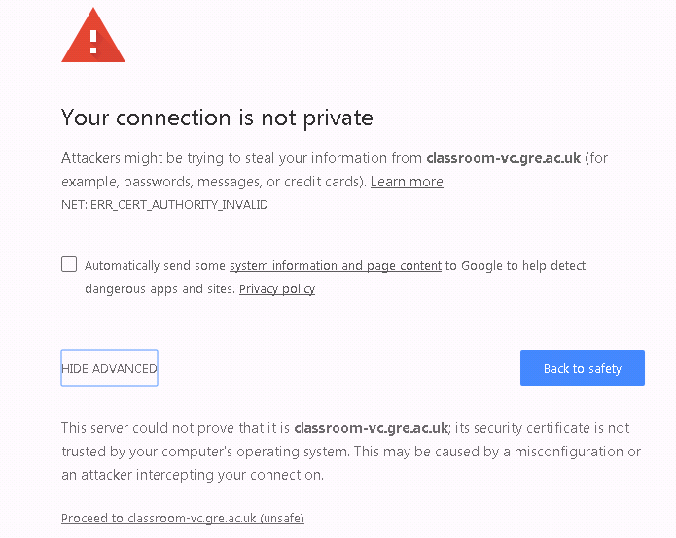

On the next screen click on Login to vSphere Web Client link:

2. Log in using your Portal username and password.
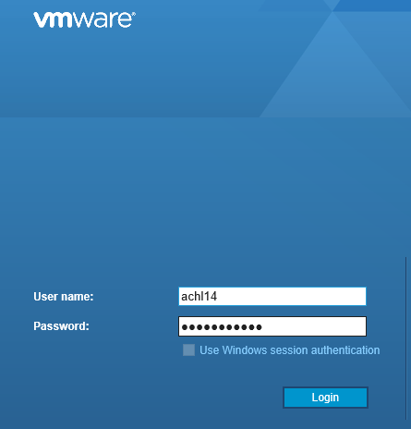

If asked about Adobe Flash Player, select install.

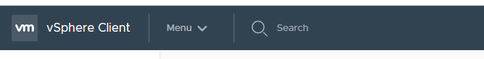
3. Once logged in, the quickest method of finding your machine is to start typing it’s name, or the course code of the course you are studying in.
Click on the machine name (highlighted) when you have found it.

4. The first time you use your machine, you may need to power it on. To do this, start your remote console connection
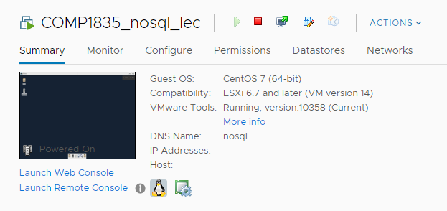

Allow the machine to boot.

5. Your Linux should open with automatic login

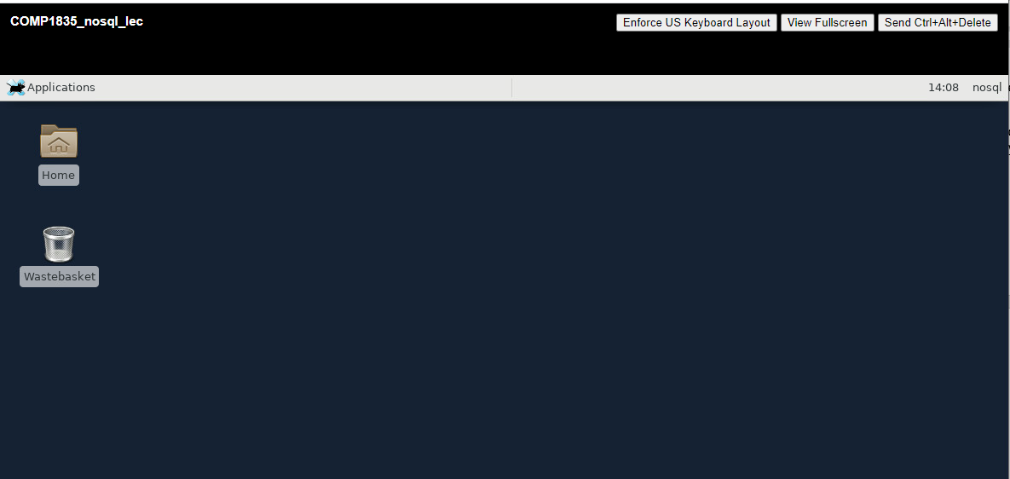

7. Make yourself familiar with the Linux OS (see separate document for the useful Linux information on Moodle course page)

Troubleshooting:

If at any point in time you get a problem with your VM, the first step of troubleshooting is to reboot it, by going to the VMWare window and under Actions menu choose Power-> Reset

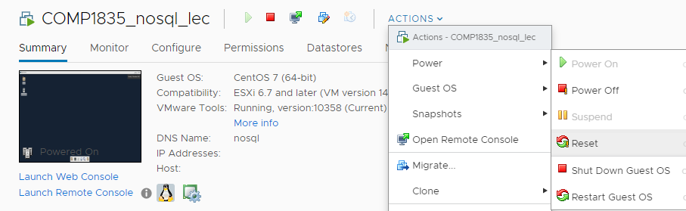

If this doesn’t solve the problem, please email FLAS_systems@gre.ac.uk with the detailed description of your problem including the VM number and nessesary screenshots.

